GRADE: XII PERIODIC TEST – II DATE: 18/7/22
MARKS: 40 BIOLOGY (044) TIME: 1½ Hrs

General instruction:
SECTION A Questions 1 to 5 carries 1 mark.
SECTION B Questions 6 to 10 carries 2 marks.
SECTION C Questions 11 to 15 carries 3 marks.
SECTION D Questions 12 & 13 carries 5 marks.

SECTION -A

I. Choose the best answer for the following: (1X5=5)

1. Which of the following statement regarding female reproductive system is (are) correct?

(i) Myometrium undergoes strong contraction at the time of delivery of baby.

(ii) Ovary is secondary female sex organ which produces female gamete and steroid hormones

(iii) Ovarian stroma is divided into two zones: inner cortex and outer medulla.

(iv) Infundibulum possess finger like projections which help in collection of ovum after the release of secondary oocyte.

(v) A functional mammary gland is the characteristic of all the mammals (including male and female).

A) (ii) and (iv) B) (i), (ii), (iii) and (v)

C) (iii), (iv) and (v) D) All of the above

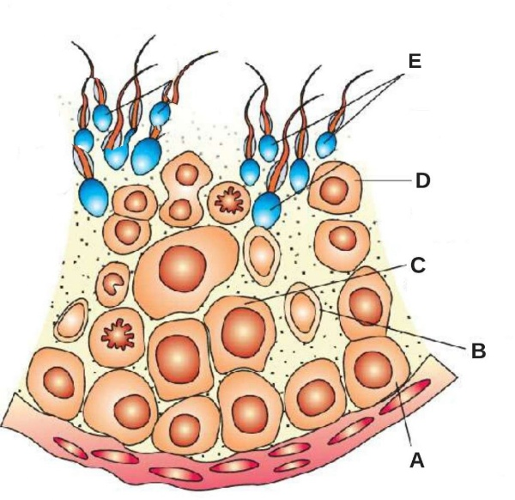
2. The given figure shows a sectional view of a seminiferous tubule. Identify the parts labelled as A, B, C, D and E.

A) A- Sertoli cells, B- Spermatogonium, C- Primary spermatocyte, D- Secondary spermatocyte, E- Spermatid

B) A- Spermatogonium, B- Sertoli cells, C- Primary spermatocyte, D- Secondary spermatocyte, E- Spermatozoa

C) A - Sertoli cells, B-Spermatozoa, C- Secondary spermatocyte, D -Primary spermatocyte, E – Spermatids

D) A- Sertoli cells, B- Spermatogonium, C- Primary spermatocyte, D -Secondary spermatocyte, E- Spermatozoa

3. Match column-I with column-II and choose the correct option.
 | Column-I |  | Column-II
A. | Hyaluronidase | I. | Graafian follicle
B. | Corpus luteum | II. | Mammary gland
C. | Colostrum | III. | Progesterone
D. | Antrum | IV. | Acrosomal reaction

A) A-II; B-I; C-IV; D-III B) A-IV; B-II; C-III; D-I

C) A-IV; B-III; C-II; D-I D) A-IV; B-III; C-I; D-II

.
4. Identify the correct labellings in the diagram.
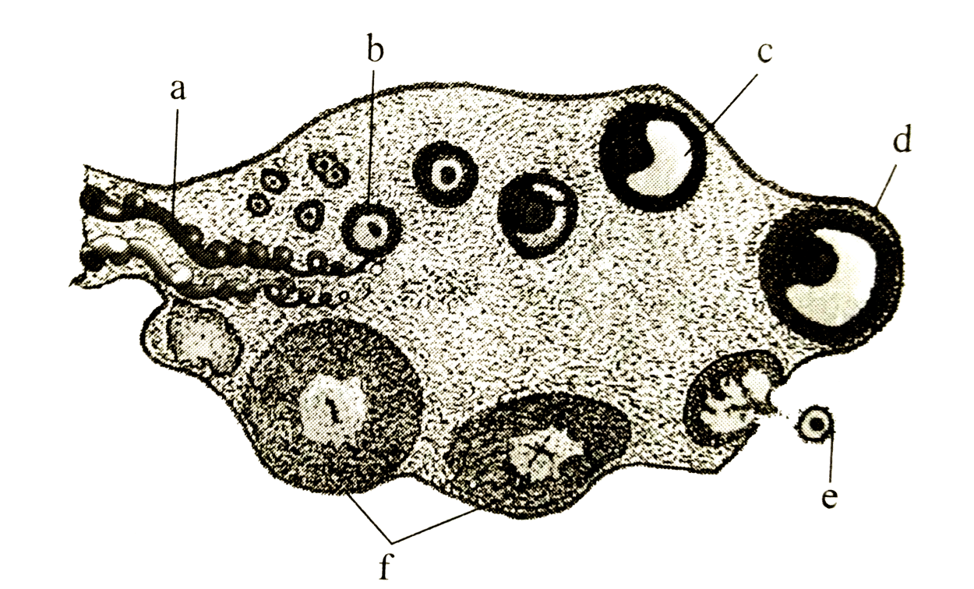
A. a-blood vessel, b-primary follicle, c-tertiary follicle, d-Graafian follicle, e-ovum, f-corpus luteum
B. a-primary follicle, b-blood vessel, c-tertiary follicle, d-Graafian follicle, e-ovum, f-corpus luteum
C. a-blood vessel, b-primary follicle, c-tertiary follicle, d-ovum, e-Graafian follicles, f-corpus luteum
D. a-ovum, b-Graafian follicle, c-corpus luteum, d-blood vessel, e-primary follicle, f-tertiary
5. The below diagram describes the changes that occur in the endometrium during a normal menstruation. Choose the option with correct description for points A, B, C and D.

A.A-Ovulation, B-menstruation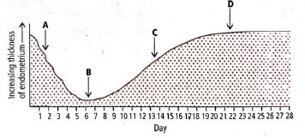
B.A-Ovulation, C-menstruation
C.A- menstruation, C- Ovulation
D.B- Ovulation, D- menstruation

SECTION-B
II. Short answer type question: (5X2=10)
6. Where does fertilisation occur in humans? Explain the events that occur during this process.
7. Explain the events that occur during fertilisation of an ovum in humans. How is it that only one sperm enters the Ovum?
8. (i) Where do the signals for parturition originate in humans?
(ii) Why is it important to feed the newborn babies on colostrum?
9. Name the hormones produced only during pregnancy in human female. Mention their source organ.
10. Placenta acts as an endocrine tissue. Justify.
SECTION-C
III. Answer the following briefly: (5X3=15)
11. (i) How is placenta formed in human female?
(ii) Name any two hormones which are secreted by it and are also present in a non-pregnant woman.

12. Compare and contrast Graafian follicle and Corpus luteum.
13. Explain the steps in the formation of an ovum from an oogonium in humans.
14. Give the names and functions of the hormones involved in the process of spermatogenesis. Write the names of the endocrine glands from where they are released.
15. Give reasons for the following:
(i) The human testes are located outside the abdominal cavity.
(ii) Some organisms like honeybees are called parthenogenic animals.
SECTION-D
IV. Give detail answer for the following: (2X5=10)
16. (i) Draw a labelled diagram of the human female reproductive system.
(ii) Enumerate the events in the ovary of a human female during
(b) Luteal phase of menstrual cycle
(a) Follicular phase
17. Read the given passage and answer the following questions.
Cleavage is the mitotic division which starts as the zygote moves through the isthmusof the oviducttowards the uterus and forms2, 4, 8, 16 daughter cells called as blastomeres.The embryo with 8 to 16 blastomeres is called a morula.
The morula divides further as it moves further in to the uterus and transforms into blastocyst. Theblastomeres in the blastocyst are arranged in to an outer layer called trophoblast and inner mass of cells attached to trophoblast is called as inner cell mass.
The trophoblast layer then gets attached to the endometrium of the uterus and the inner cell mass divide to cover the blastocyst hence blastocyst becomes embedded in the endometrium of the uterus and the process is called as implantation.

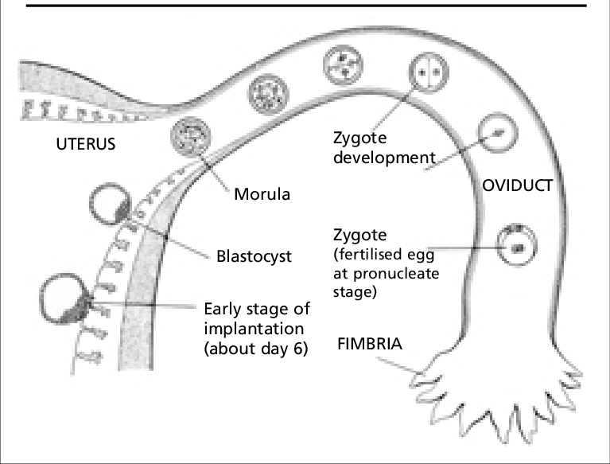
- State the fate of the trophoblast of a human blastocyst at the time of implantation and that of the inner cell mass immediately after implantation.
- Mention any two characteristics of the morula stage.
c. Study the given figure below and answer the questions that follow:
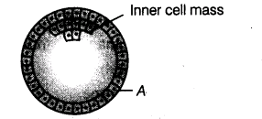
(i) Name the stage of human embryo the figure represents.
(ii) Identify A in the figure and mention its function.
(iii) Mention the fate of the inner cell mass after implantation in the uterus.
(iv) Where are the stem cells located in this embryo?

